Excel Assignment - 6

1.What are the various elements of the Excel interface? Describe how they're used.

A. After opening excel the basic elements are Active cell, Column headings, Formula bar, Name box, Row heading, Sheet tabs, Task Pane, Toolbars.

Active cell - A cell which is currently selected. It will be highlighted by a rectangular box and its address will be shown in the address bar. You can activate a cell by clicking on it or by using your arrow buttons.

Column headings - A column is a vertical set of cells. A single worksheet contains 16384 total columns. Every column has its own alphabet for identity, from A to XFD. You can select a column clicking on its header.

Formula bar - The formula bar is an input bar, below the ribbon. It shows the content of the active cell and you can also use it to enter a formula in a cell.

Name box - The Name Box displays the cell that is currently selected in the spreadsheet. It is located to the left of the formula bar. If a name is defined for a cell that is selected

Row Heading - A row header is the column at the left of the table that identifies each row within the table. Row headers are needed if the cells in a column identify the contents of the row, in effect providing a label for the row. These labels are often a key or ID column for the rest of the data.

Sheet tabs - In Microsoft Excel, a sheet, sheet tab, or worksheet tab is used to display the worksheet that a user is currently editing. By clicking a worksheet tab (located at the bottom of the window), users may move between the various worksheets.

Task Pane - Task panes are interface surfaces that typically appear on the right side of the window within Word, PowerPoint, Excel, and Outlook. Task panes give users access to interface controls that run code to modify documents or emails, or display data from a data source.

Toolbars - The Toolbar is an area where you can add different commands or tools associated with excel. By default, it is located above the ribbon with different tools and visible in the Excel window's upper right corner.

2. Write down the various applications of Excel in the industry.

A. Various applications are :

1. Calculating
2. Accounting
3. Charting
4. Inventory tracking
5. Calendars and schedules
6. Seating charts
7. Goal planning worksheets
8. Project management
9. Time logs
10. Business analysis

3. On the ribbon, make a new tab. Add some different groups, insert commands in the groups and name them according to their commands added. Copy and paste the screenshot of the steps you followed.

Ans :

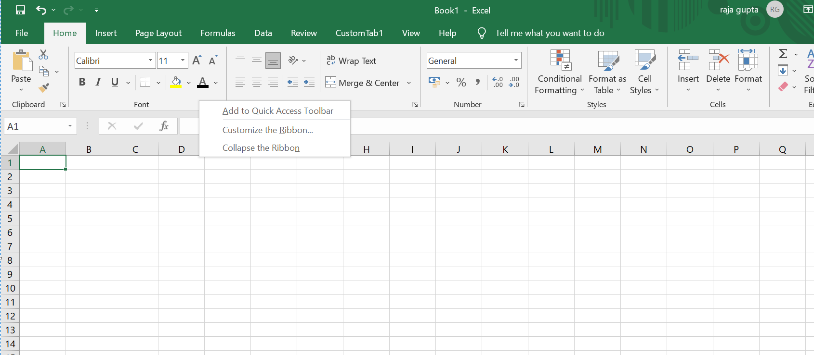

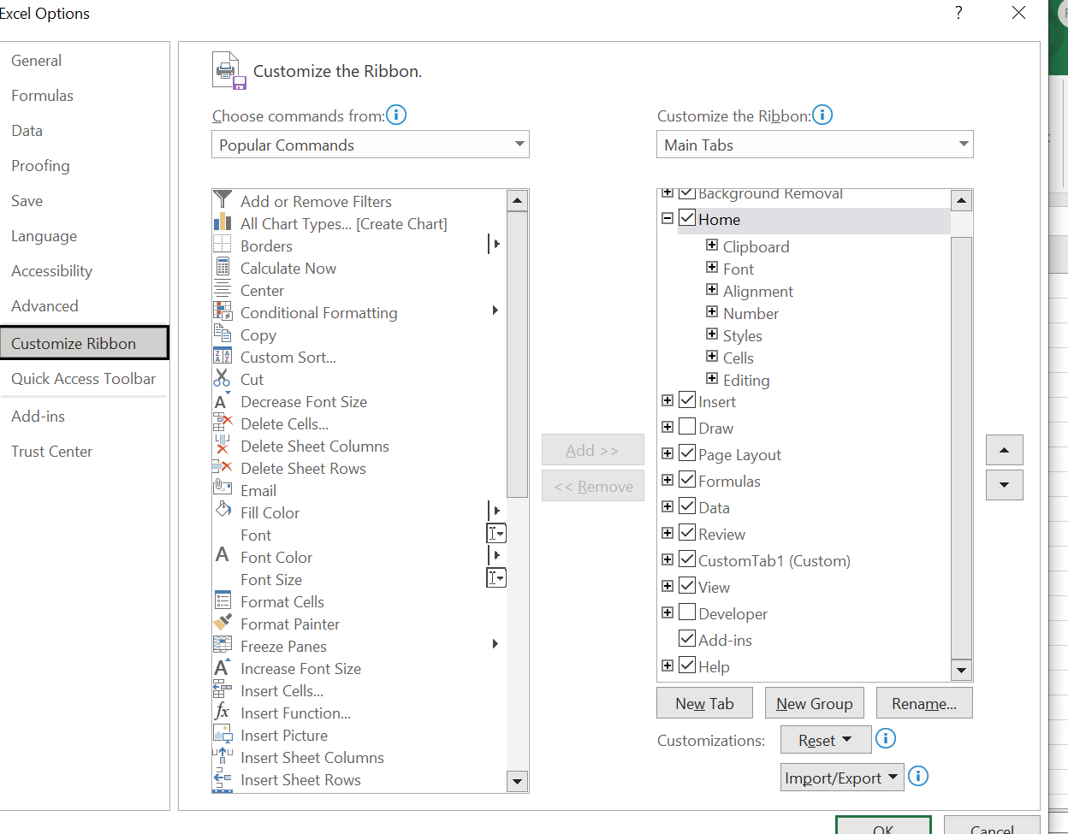

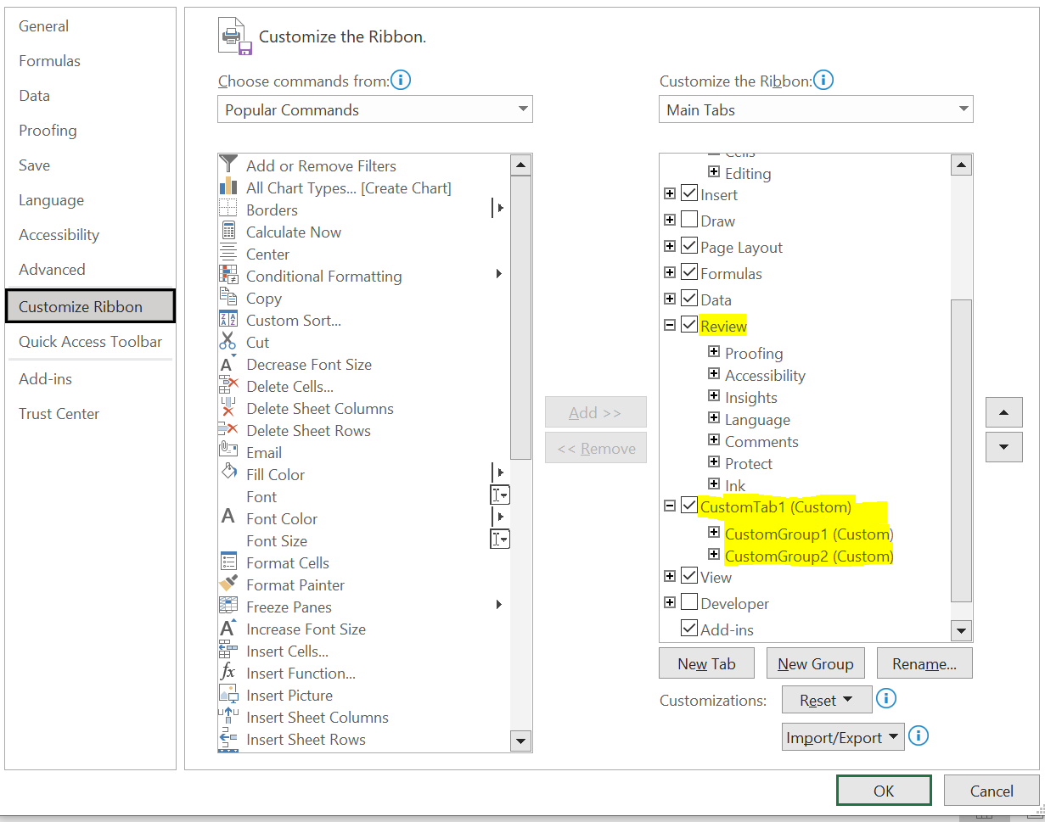

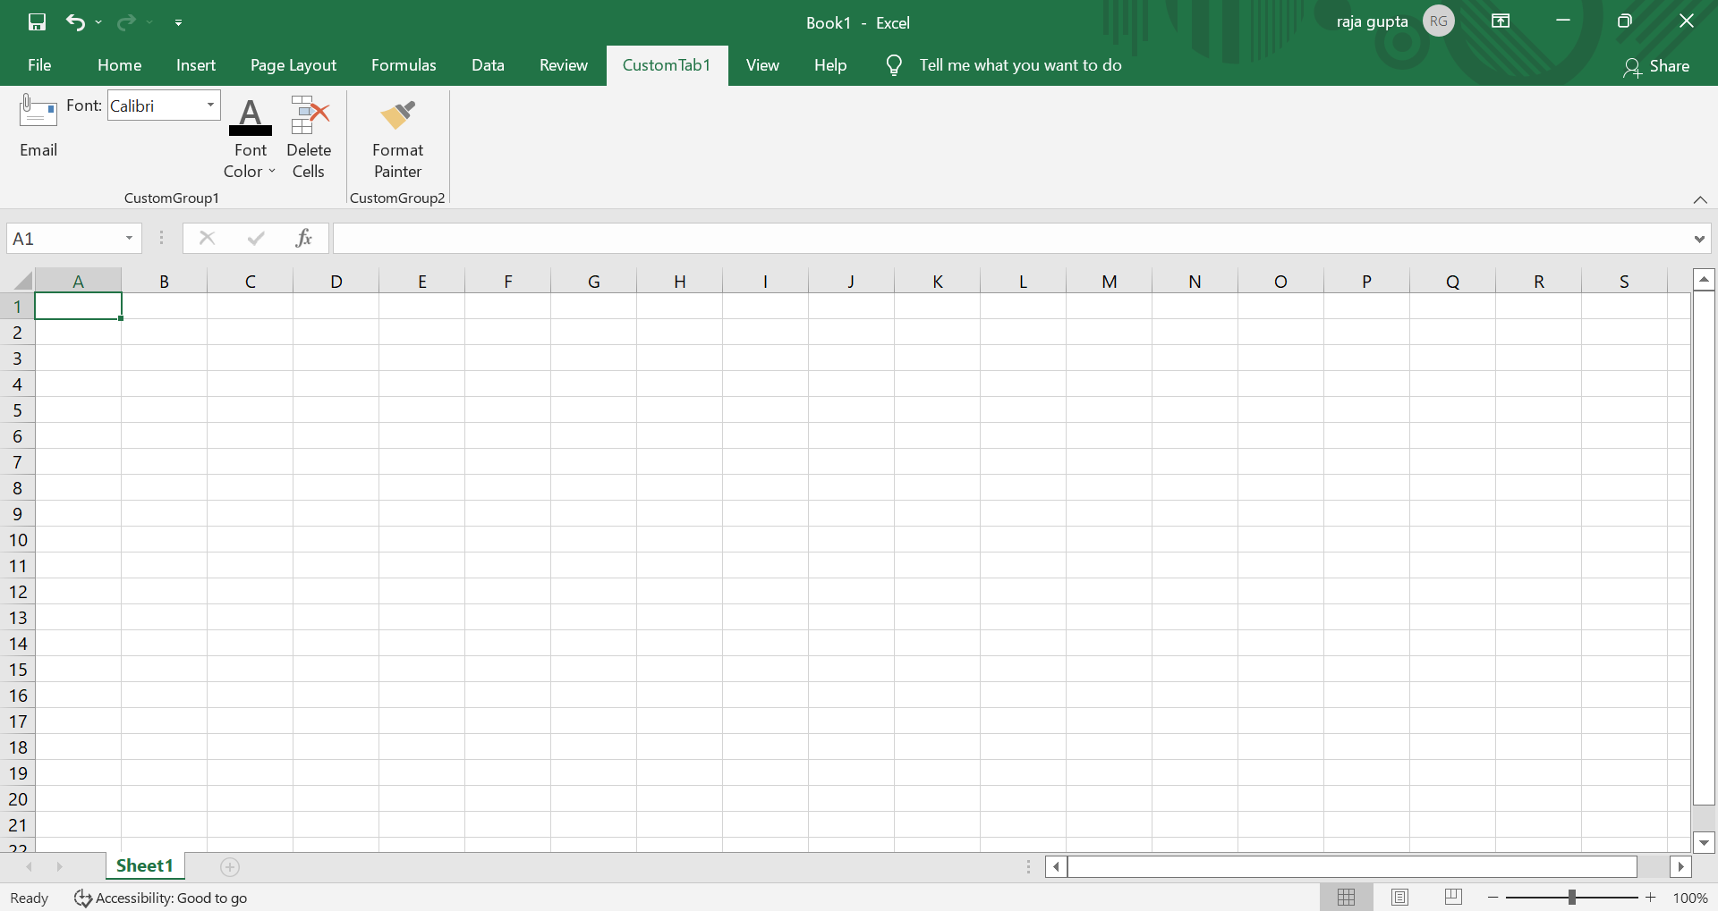

4. Make a list of different shortcut keys that are only connected to formatting with their functions.

A.

|  |  |
| --- | --- |
| Choose a fill color. | Alt+H, H |
| Cut selection. | Ctrl+X |
| Go to the **Insert** tab. | Alt+N |
| Apply bold formatting. | Ctrl+B |
| Center align cell contents. | Alt+H, A, C |
| Go to the **Page Layout**tab. | Alt+P |
| Go to the **Data** tab. | Alt+A |
| Go to the **View** tab. | Alt+W |
| Open the context menu. | Shift+F10 or  Windows Menu key |
| Add borders. | Alt+H, B |
| Delete column. | Alt+H, D, C |
| Go to the **Formula** tab. | Alt+M |
| Hide the selected rows. | Ctrl+9 |

5. What distinguishes Excel from other analytical tools?

Answer.

1.Excel is used for formatting and organizing the data while other Analytical tools are basically

a visualization tool used for detailed analysis.

2. Main purpose of excel is to store data and statistical analysis and others are for quick and easy representation of data.

3. Drawback of excel is inbuilt security features are weak as compare to other analytical tool.

4. Business purpose of excel is quick on-off reports rather than statistical reports.

6. Create a table and add a custom header and footer to your table.

Answer:

